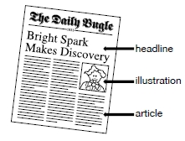
Imagine that it is 1831 and you are a newspaper journalist reporting on the work of Michael Faraday. In the template below write a front page article and create you own headline announcing his discoveries.
Use the box to draw a picture of Michael Faraday or a diagram of his experiment. You may want to enlarge the template below on a photocopier.


